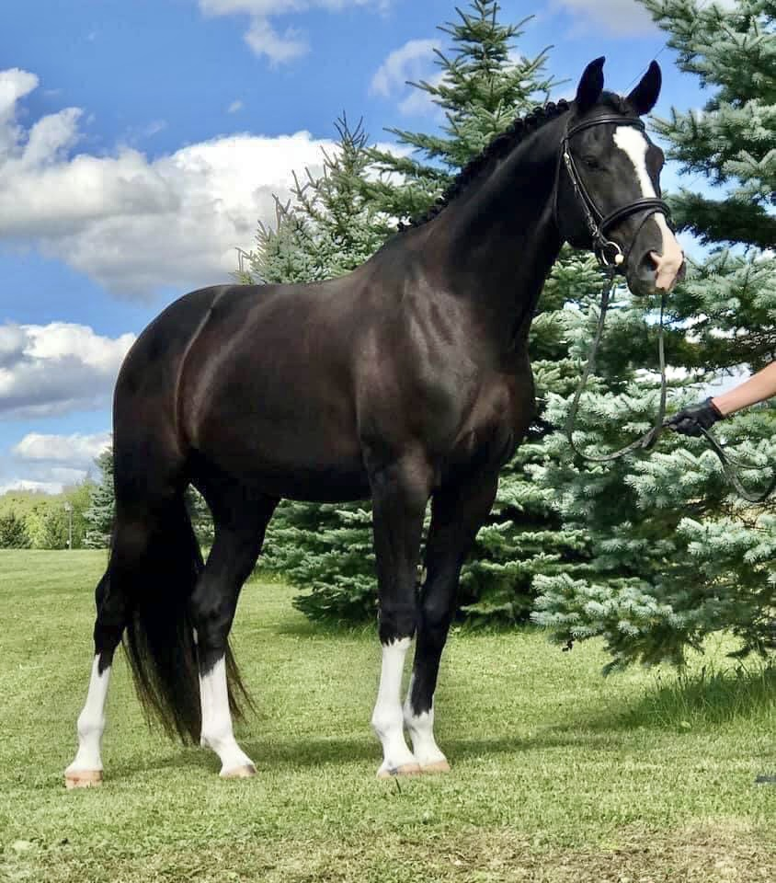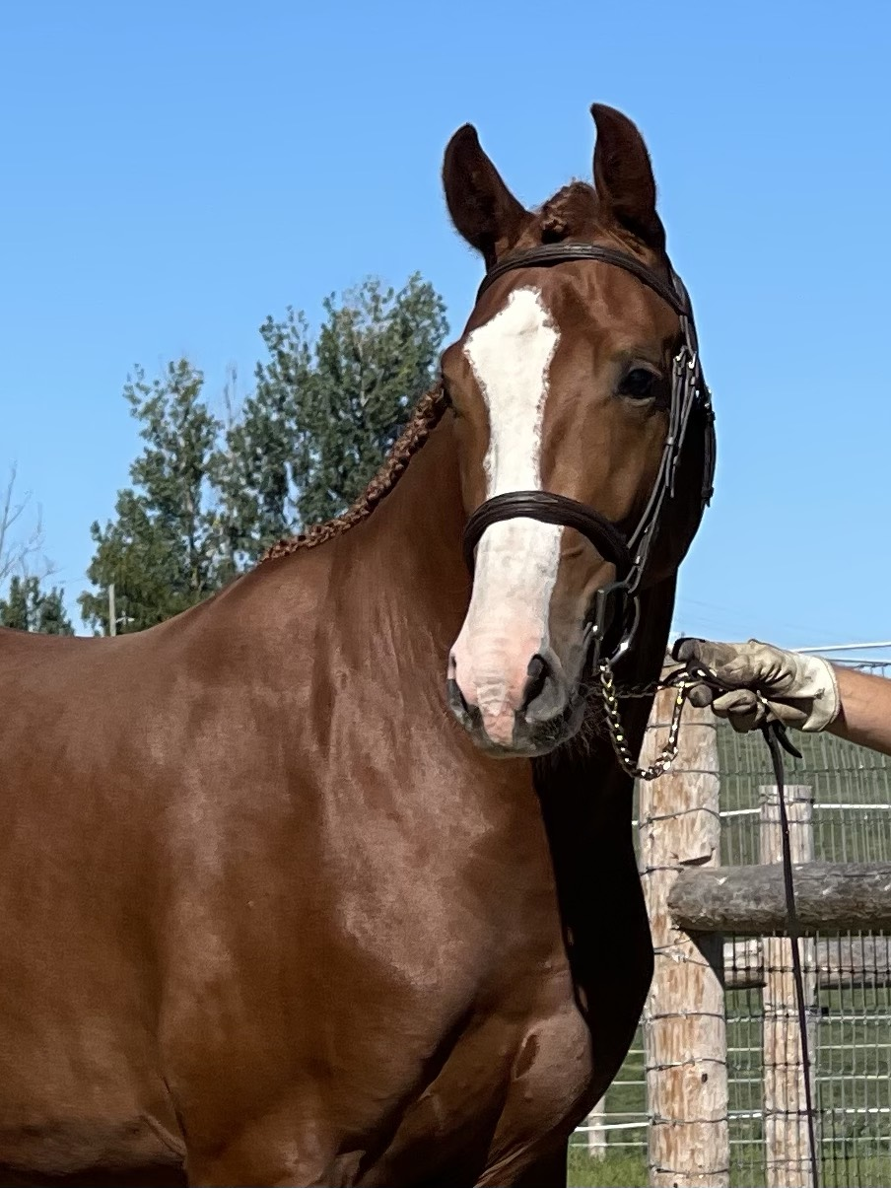

**Fox Hill Farm**

**Sheri Whittaker**

**New Dundee, Ontario,**

**Canada N0B 2E0**

**519-240-0998**

**Email:** [**foxhillfarm@hotmail.com**](mailto:foxhillfarm@hotmail.com)

**Website:** [**foxhillfarmequestrian.com**](http://foxhillfarmequestrian.com)

**BREEDING AGREEMENT FOR FOX HILL FARM STALLIONS**

Please check here to breed to

**SIR VARI**

**SIR VARI**

2017 Black Hanoverian Stallion (Sir Wanabi x Bon Balou)

Canadian Hanoverian Verband

EVA and WFFS negative

**LAS VEGAS**

2020 Chestnut Rhineland Stallion (Lestat OLD x Bon Balou)

Canadian Rhineland Verband

EVA and WFFS negative

Please check here to breed to

**LAS VEGAS**

This document constitutes the Breeding Agreement between ___________________________, hereinafter referred to as the **Mare Owner**, and **Fox Hill Farm/Sheri Whittaker**, hereinafter referred to as the **Stallion Owner**, on this date __________________, in respect to the breeding of Sir Vari or Las Vegas, hereinafter referred to as the **Stallion**, and _______________________, hereinafter referred to as the **Mare**, subject to the following:

**TERMS AND CONDITIONS:**

1. 2023 breeding fees:  
   **Sir Vari** (DE431316930717) - $1700 CAD (plus HST)  
   **Las Vegas** (DE431439820420) - $1100 CAD (plus HST) **(promo pricing for 2023 season)**  
   Payment is due upon the signing of this agreement.   
   Payable to the Stallion Owner via E-transfer to Sheri Whittaker [foxhillfarm@hotmail.com](mailto:foxhillfarm@hotmail.com) or all major credit cards are accepted. **No semen will be shipped without full payment.**
2. The collection fee is included with the first semen shipment. All subsequent shipments will incur the collection fee of $325 CAD (plus HST). The credit card provided by the mare owner will be charged for any subsequent collection requests made.   
     
   **Initial here: __________________**
3. Shipping fee via FedEx is payable by the Mare Owner. A credit card and or FedEx customer account number is required prior to shipment. The Stallion Owner and stallion collection manager hold no responsibility for mishandling by Fed Ex for any shipment issues, lost or late shipments. Any resulting claims are the sole responsibility of the Mare Owner and shipping company directly.
4. Requests for semen must be received no later than 9:00am EST on the day of collection by text or call to 519-240-0998. Collection days are Monday, Wednesday and Friday. Collections on other days may be possible under special circumstances and must be arranged with Stallion Owner in advance. Season is from April 1st to mid-September annually.
5. The Mare Owner agrees to breed only the Mare stated within this agreement unless approval has been granted by the Stallion Owner.
6. The Mare shall be deemed in sound breeding condition as determined by a certified veterinarian.
7. Live foal guarantee: Should the Mare fail to conceive, abort, die or not produce a “live” foal (live foal shall be defined as a foal that stands and nurses without assistance for a period of 14 days from the time of birth) then the Stallion Owner guarantees the Mare Owner shall have the right to re-breed or substitute a Mare (upon the approval and discretion of the Stallion Owner) within the current or the following breeding season only. Collection fee is applicable.
8. In the case where the stallion dies, is sold, or becomes permanently unfit for breeding, the Mare Owner will be entitled to receive one dose of frozen semen as a replacement OR they can choose another Fox Hill Farm Stallion. If the stallion becomes injured or cannot be collected for any other health reasons, the Mare Owner will receive fresh semen as soon as he becomes available again for breeding.
9. This breeding agreement can be used in 2023 or the 2024 season.
10. The parties agree that the terms and conditions stated herein set forth the entire agreement of the parties.
11. The agreement shall be interpreted in accordance with the laws of the province of Ontario and its validity and administration shall be governed by said laws.
12. The termination of this contract by the Mare Owner is non-refundable in its entirety, no exceptions.
13. All sales are final.

**To be filled in by the Mare Owner:**

**Mare Owner Information:**

Name: ________________________________________________________________________

Home address: _________________________________________________________________

______________________________________________________________________________

Shipping address (if different from above): ___________________________________________

______________________________________________________________________________

*Mare Owner credit card information will be used for FedEx shipping and subsequent collections*

Credit card number: _____________________________________________________________

Expiry date: ________________________ CSV: __________________________

FedEx account number: __________________________________________________________

**Mare Information:**

Barn name: ____________________________________________________________________

Registered name: _______________________________________________________________

Breed: ________________________________________________________________________

Registration number: ____________________________________________________________

What stallion are you breeding to (Sir Vari or Las Vegas)? _______________________________

Mare Owner Signature: ___________________________________ Date: _________________

Stallion Owner Signature: _________________________________ Date: __________________